User Documentation
Introduction:
User:
Users can monitor, manage, and analyze sensor and team activity through the SNAKE system dashboard. By accessing different sections of the platform, engineers and managers can track real-time sensor data, observe performance trends, and review team contributions. The dashboard includes key functional areas such as Control Center, Statistics, Teams, Team Overview, Chatbot, and Rates — each offering focused insights and tools.
Both engineers and managers can monitor live data from various sensors, including indoor and outdoor temperature, humidity, air pressure, distance, and daylight intensity (Dlight).
In addition to monitoring data, managers can assign tasks to engineers, where each task carries a predefined score to support performance tracking and fair evaluation. The integrated chatbot enables users to ask technical or operational questions — such as about sensor behavior or system functions — and receive immediate, relevant responses.
Navigation Guide:
- Click on the Control Center button, and then you will go to the manager dashboard where you can monitor system status, assign tasks, handle anomalies, and manage engineers and teams.
- Click on the Search button, and then you will go to the search page, where you can search for terms from the MQTT website and view links to relevant pages with the number of appearances of the terms.
- Click on the Statistics button, and then you will go to the data visualization page showing sensor graphs, value distributions, and weekly reports.
- Click on the Teams button, and then you will go to the meetings management page where you can schedule, update, or delete team meetings.
- Click on the Rates button, and then you will go to the engineer ranking page showing points and task performance of individual engineers.
- Click on the Chatbot button, and then you will go to the chatbot page where you can ask questions about the system and get intelligent responses based on your data.
- Click on the Team Overview button, and then you will go to the page that presents the rankings and performance of the different teams.

Control Center
The central control panel is designed for the system manager to monitor and manage the status of the system, teams, and engineers. This screen provides a general and up-to-date summary of the system’s status over a specified monitoring period, allowing the manager to gain a complete and accurate overview of the system’s operation.
The screen displays general system data, including the number of active sensors, the teams, and the engineers serving the system.
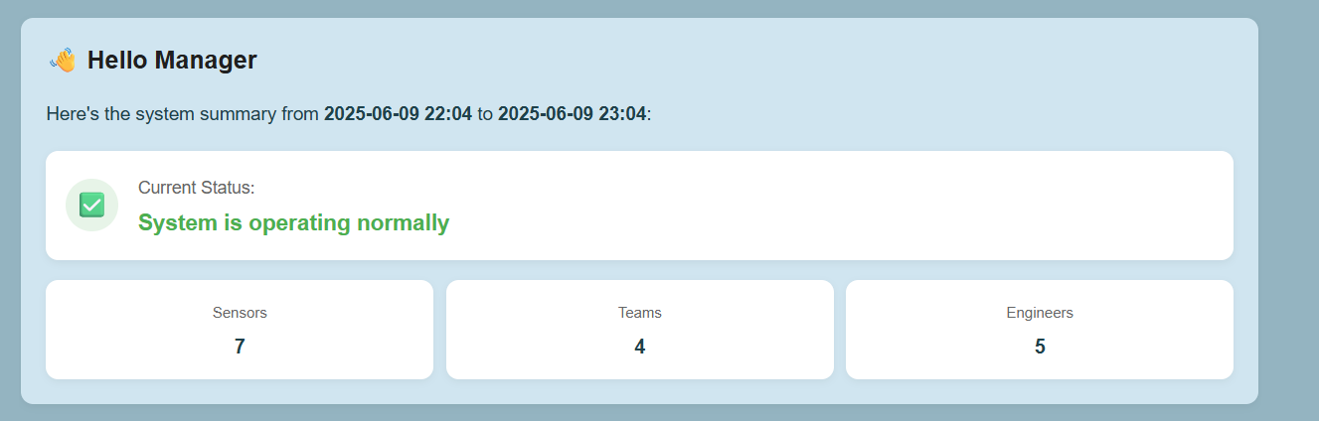

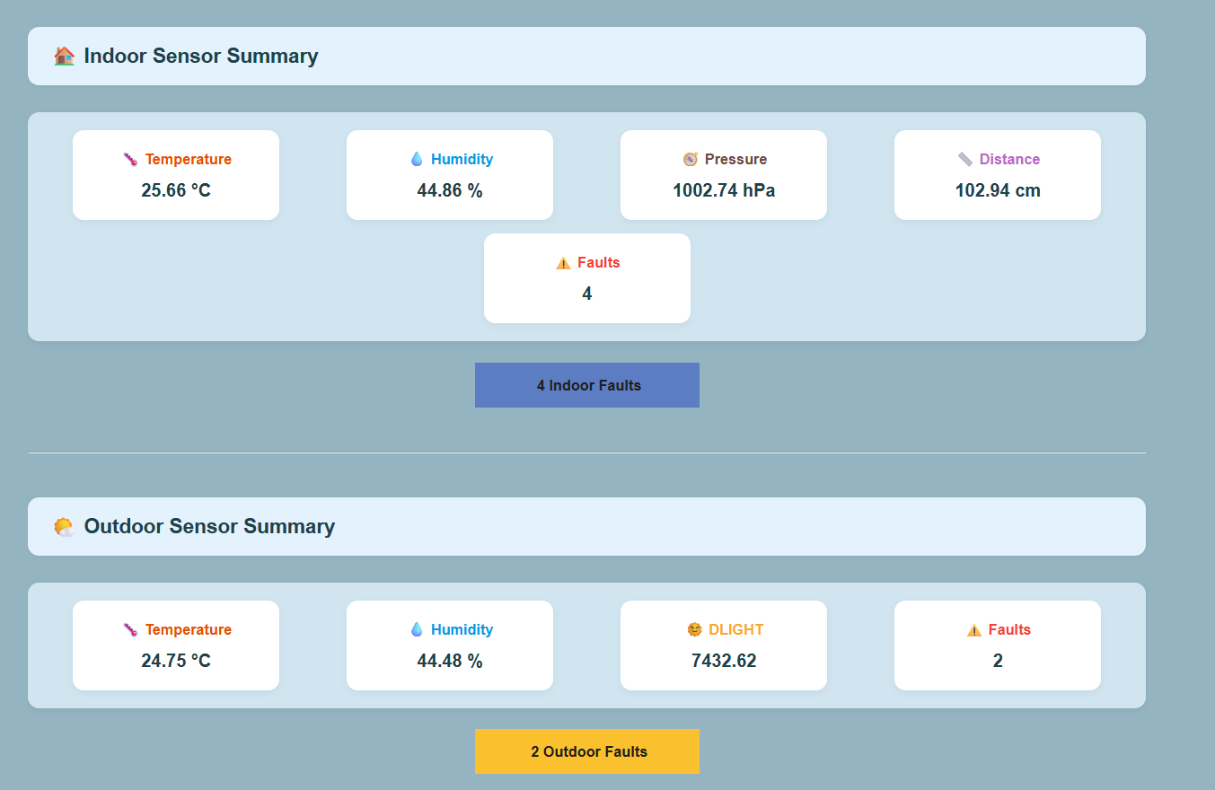
Additionally, it presents a detailed summary of internal and external sensor data, with errors detected alongside the measurements and options to access further details about each error.
After clicking the
4 Indoor Faults" button"
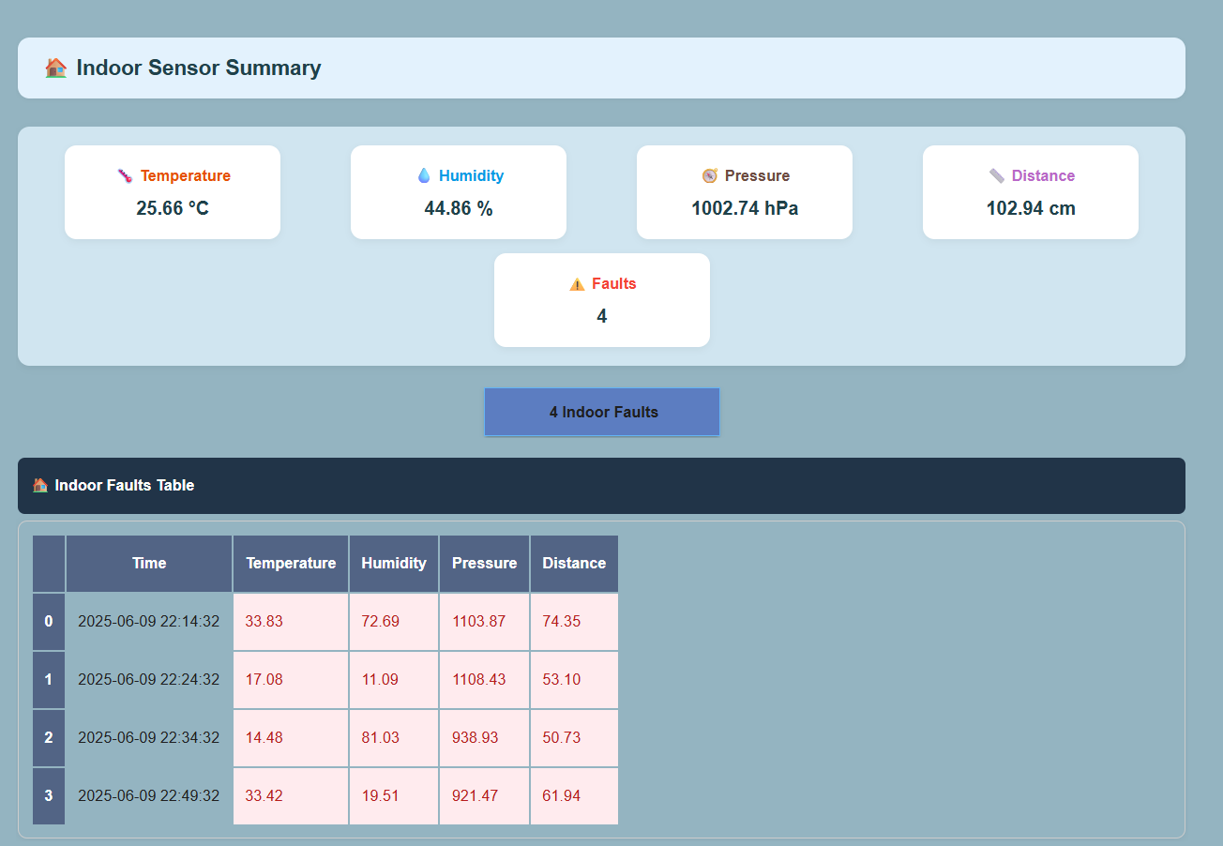
Furthermore, a button is provided to display the weekly fault summary report, enabling an in-depth analysis of the faults that occurred during the week.
button"View Summary Report"After clicking the


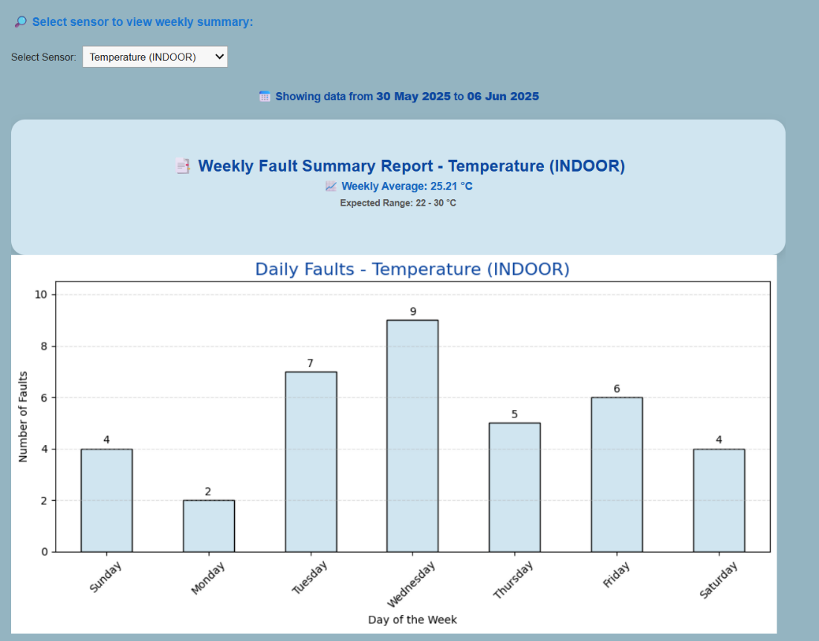
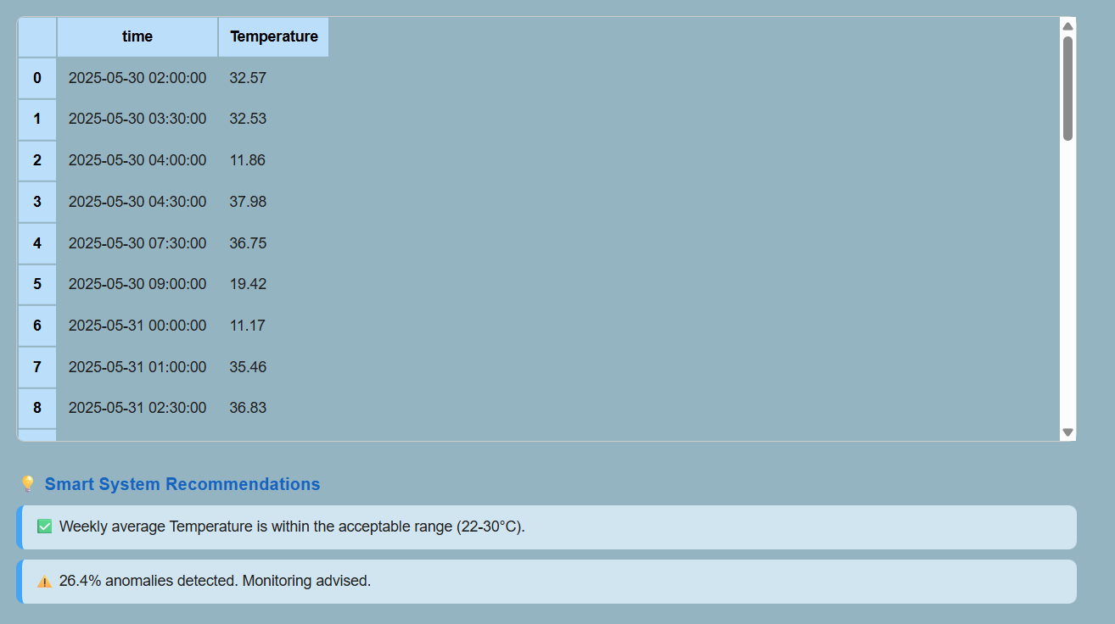

The screen also offers smart suggestions aimed at providing practical solutions for improving the system or addressing potential issue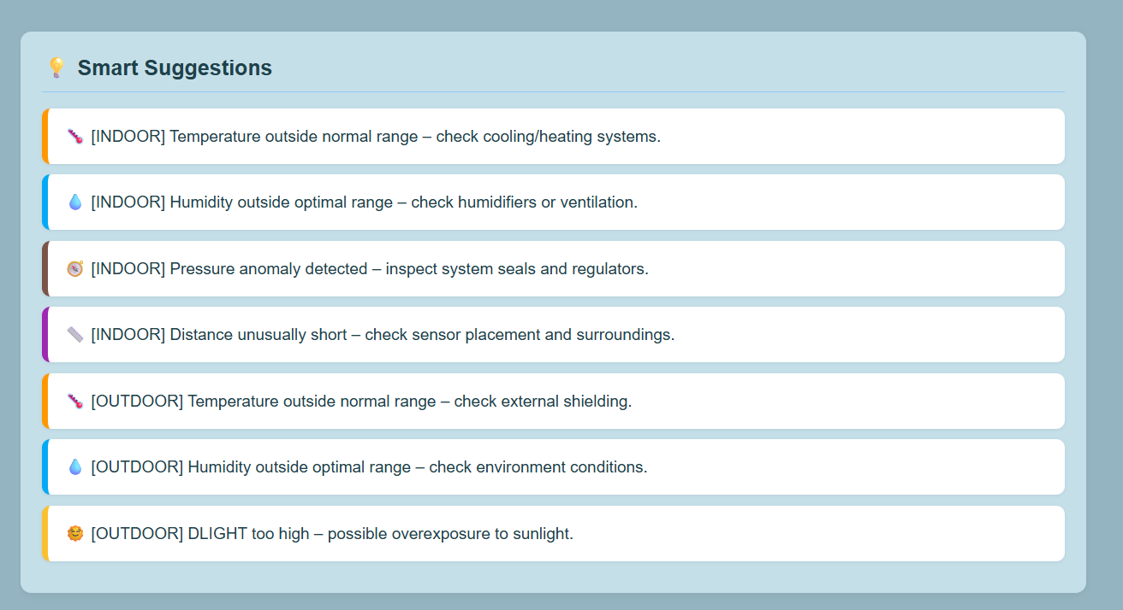The panel includes real-time critical alerts highlighting significant errors that require immediate attention.
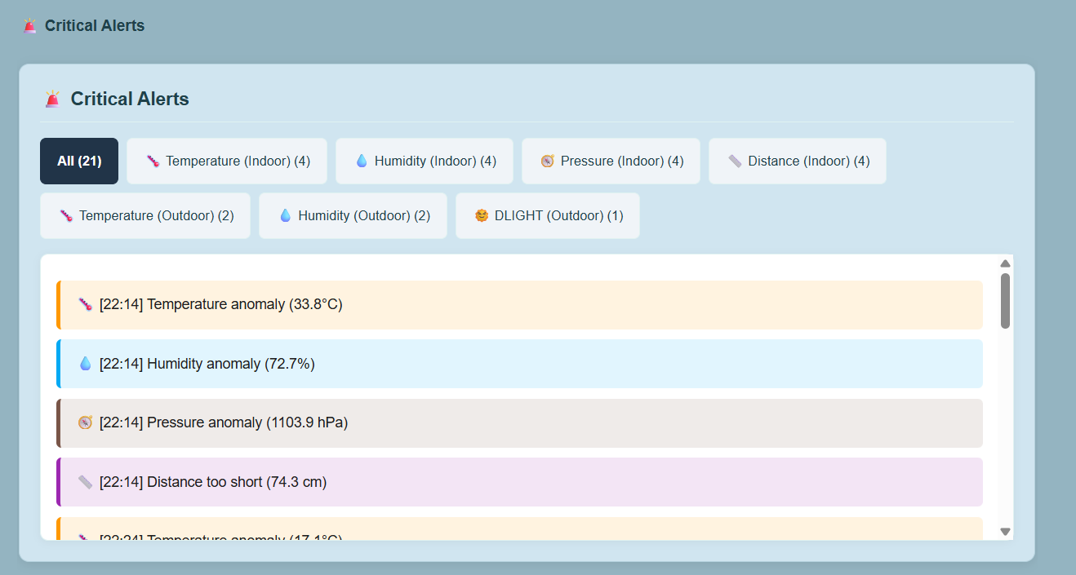

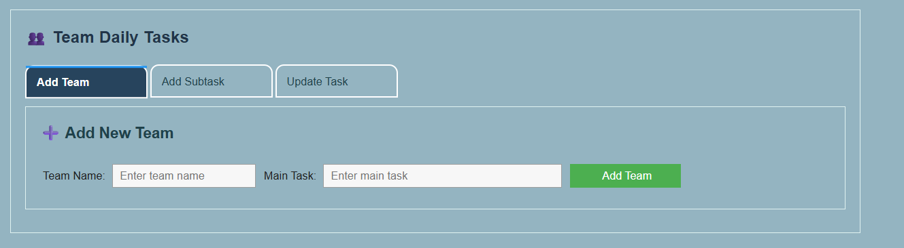
For daily team management, there are options to add and update teams and their assigned tasks.

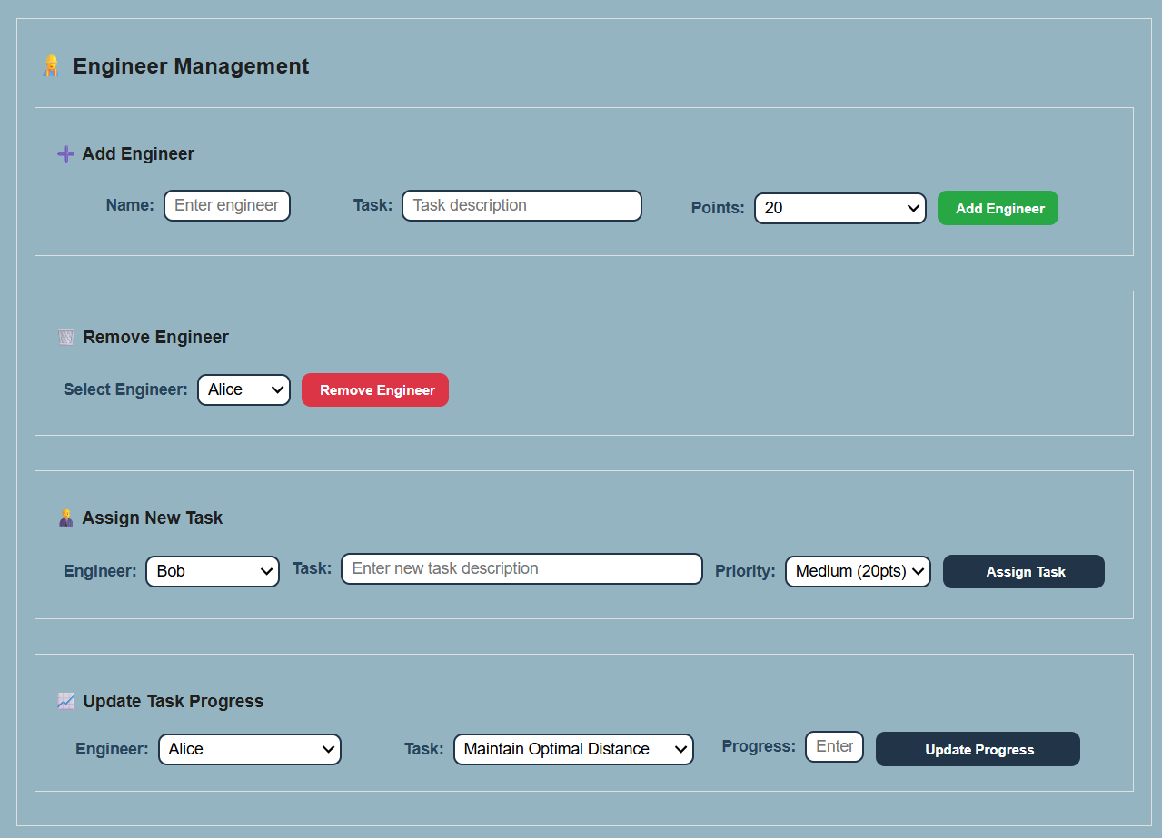
Additionally, it allows management of staff and engineers—adding and removing engineers ,assigning tasks based on priority, and update task progress .

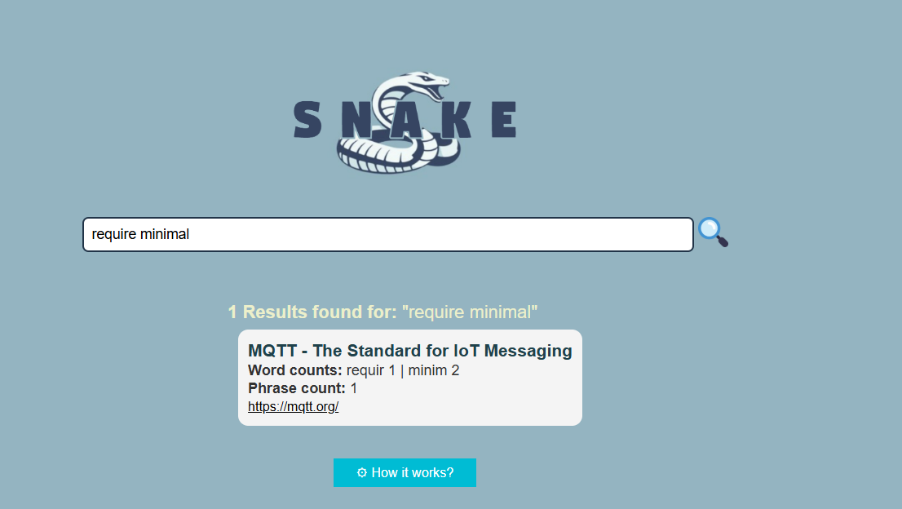
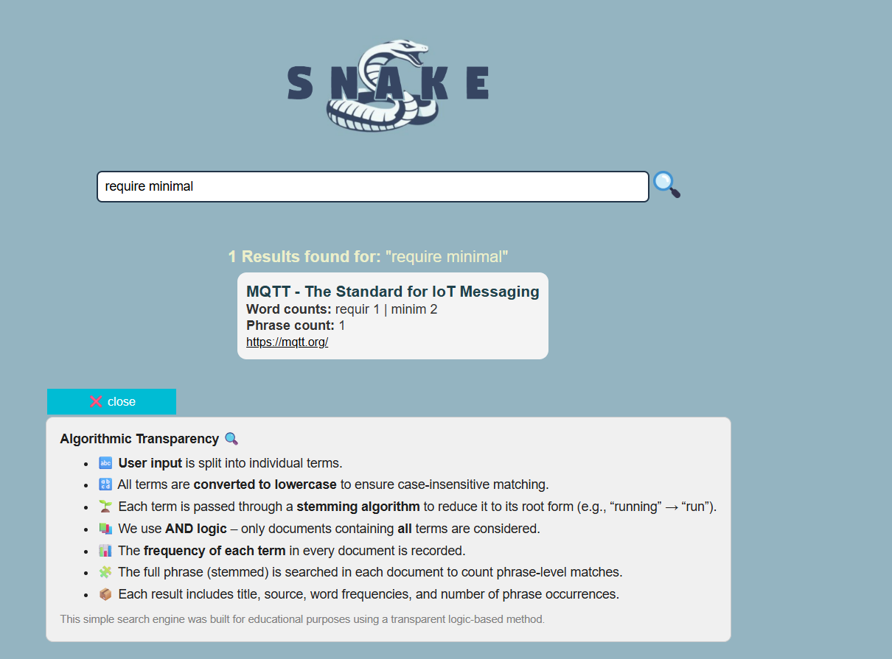
Search
The screen displays a search engine for terms from the MQTT.org site, which is used in IoT systems. The user enters a search query, and the system shows relevant results including information about the frequency of words and phrases. To ensure algorithmic transparency, the screen also provides a clear, general explanation of how the search engine works and what data is collected, helping users understand the process behind the search results.
After clicking the How it works?" button"

Statistics
The Statistics page is designed for both engineers and system managers to analyze sensor behavior and detect potential risks. This screen provides a real-time simulation environment where users can adjust sensor readings such as temperature, humidity, pressure, distance, and daylight intensity to predict system risk levels.
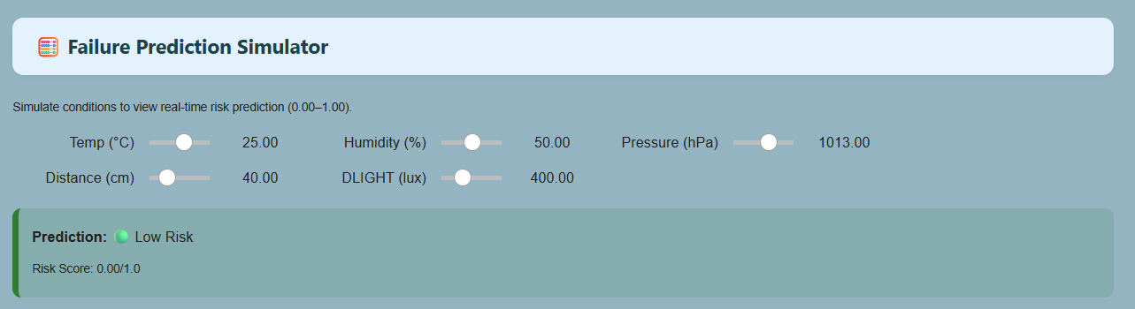
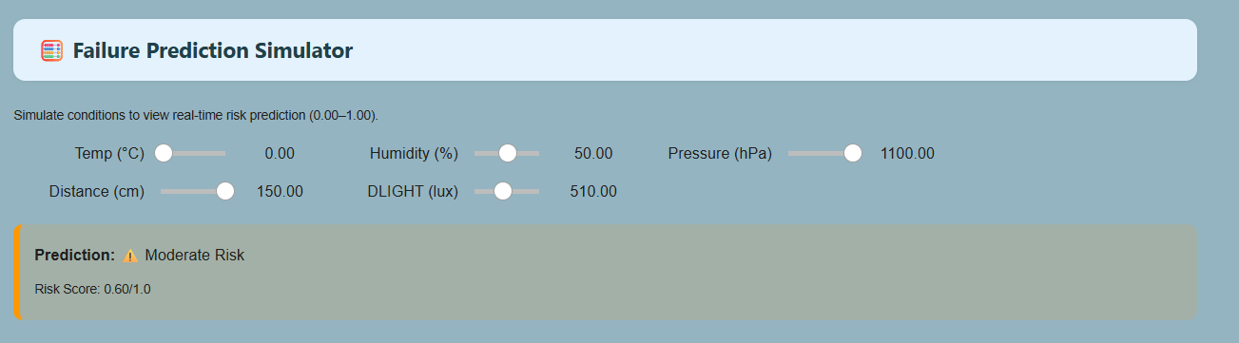
At the top of the page, the Failure Prediction Simulator allows users to adjust key sensor inputs to simulate environmental conditions. Based on these inputs, the system automatically predicts the risk level and displays a Risk Score from 0.00 to 1.00.
Additionally, the page includes a Root Cause Analysis tool, allowing users to select specific anomalies and view the most probable causes based on the current sensor data. This helps in understanding abnormal behavior, improving system reliability, and supporting data-driven decision-making.
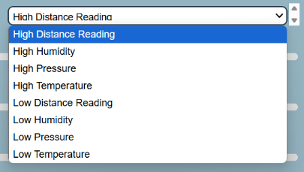
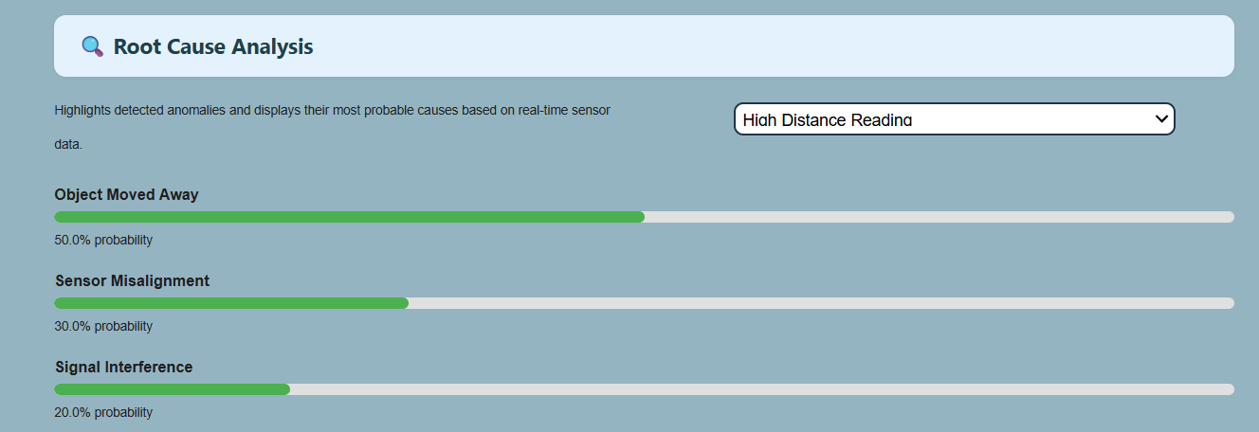

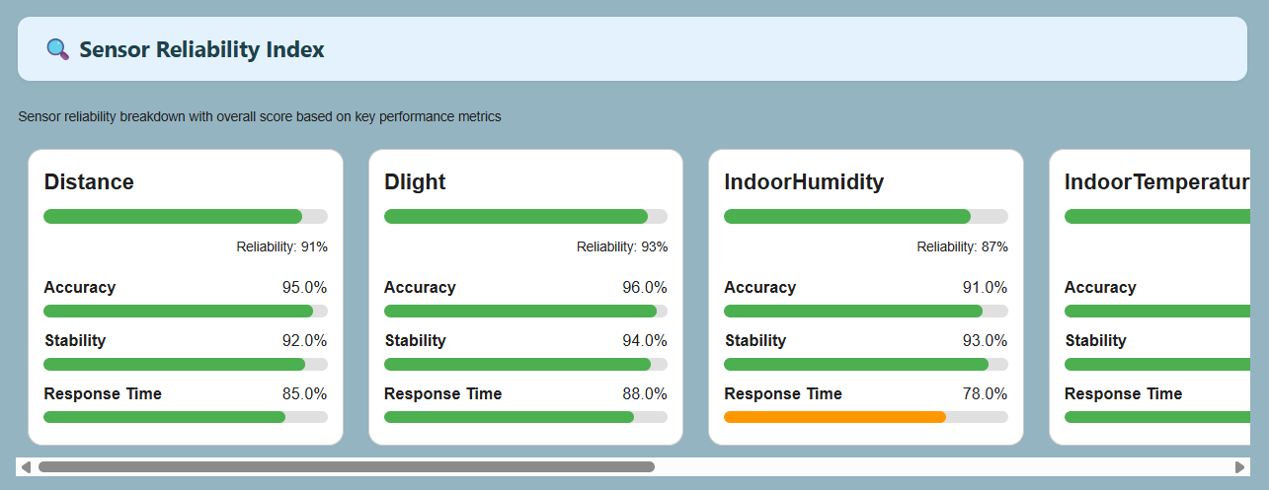
The Sensor Reliability Index section provides a detailed breakdown of each sensor's performance based on three key metrics: Accuracy, Stability, and Response Time. Each sensor is evaluated individually, and an overall Reliability Score is calculated as a summary of its trustworthiness in real-world conditions.
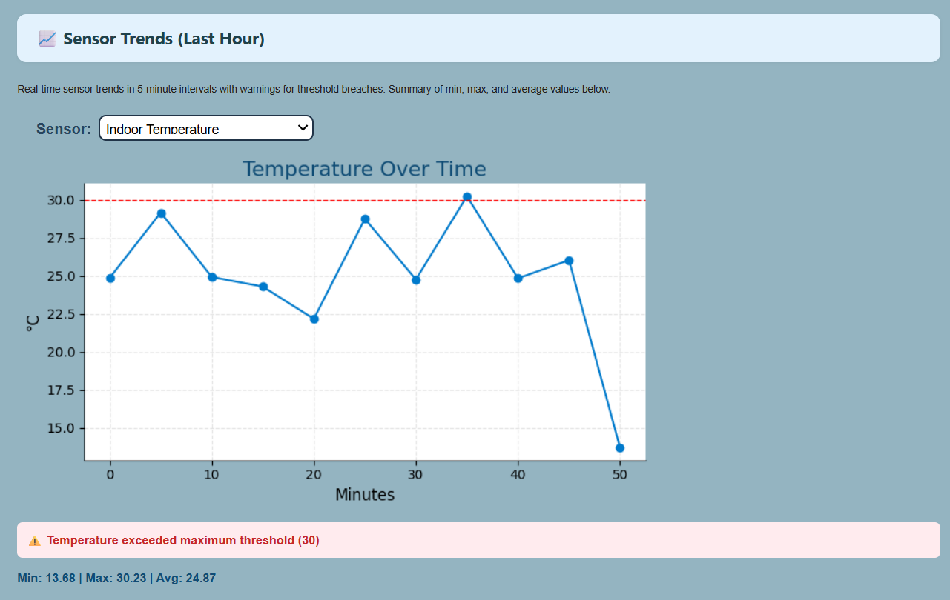
The Sensor Trends (Last Hour) section displays real-time graphs for selected sensors, showing changes over time in 5-minute intervals. If a sensor reading exceeds a defined threshold , a warning is triggered to indicate potential defects.Below the graph, minimum, maximum, and average values are summarized for clear insights.

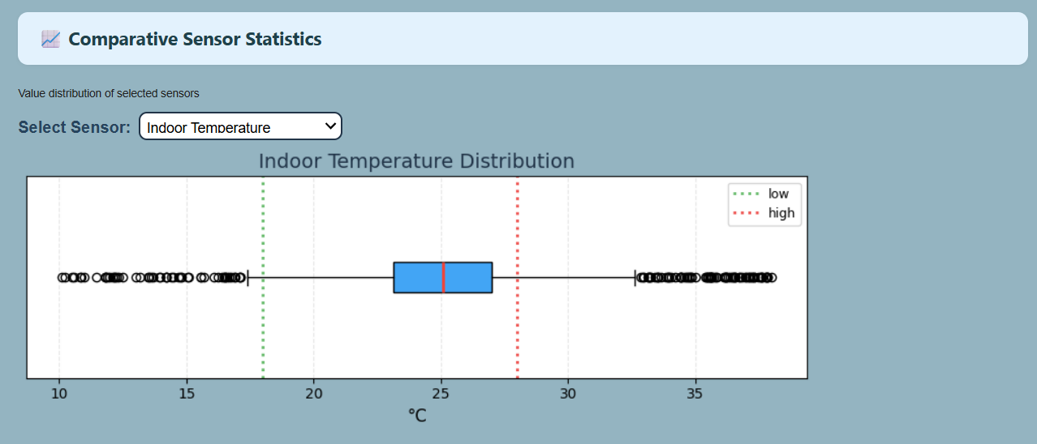
The Comparative Sensor Statistics section shows the value distribution of selected sensors using a box plot. Users can compare sensor readings and identify data spread, outliers, and median values. Green and red dashed lines mark the acceptable low and high thresholds. This helps detect abnormal patterns and compare performance between indoor and outdoor sensors.

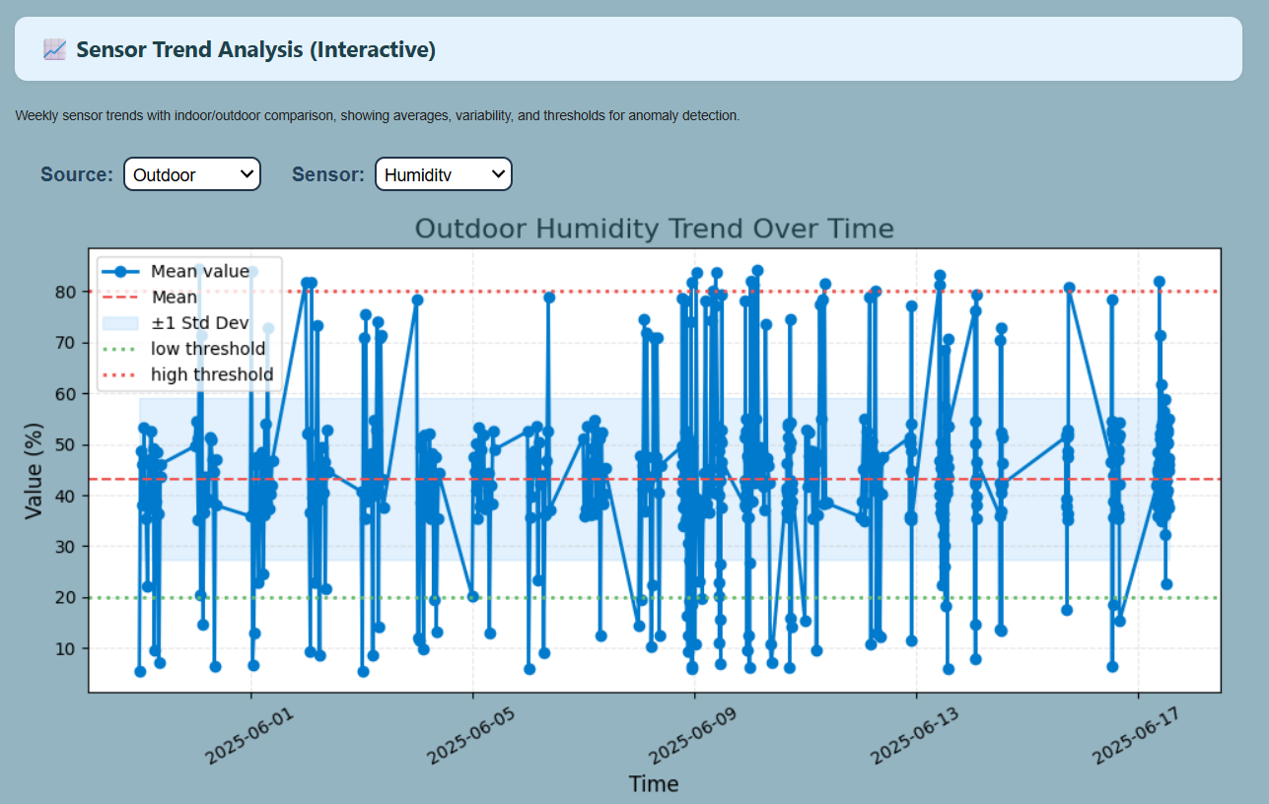
The Sensor Trend Analysis (Interactive) section shows long-term trends of selected sensor data over week. Users can compare indoor or outdoor values, along with mean, standard deviation, and threshold lines. This helps detect anomalies, variability, and overall sen sor behavior.

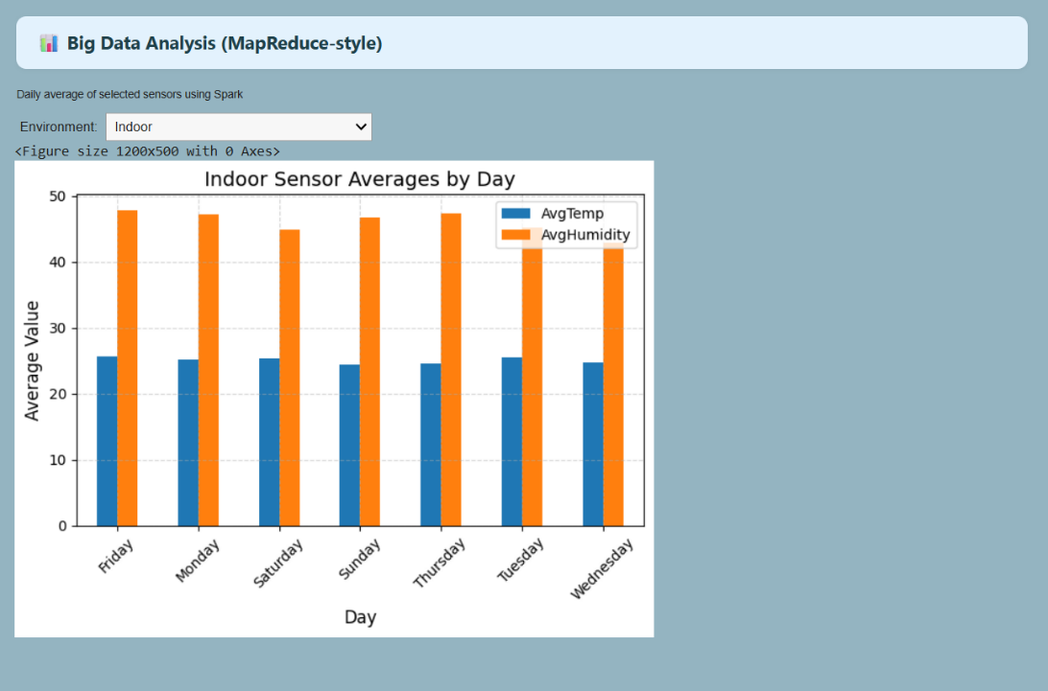
The Big Data Analysis chart shows the daily average values of indoor sensors using Spark with a MapReduce-style calculation. It compares average temperature (AvgTemp) and average humidity (AvgHumidity) across different days of the week.

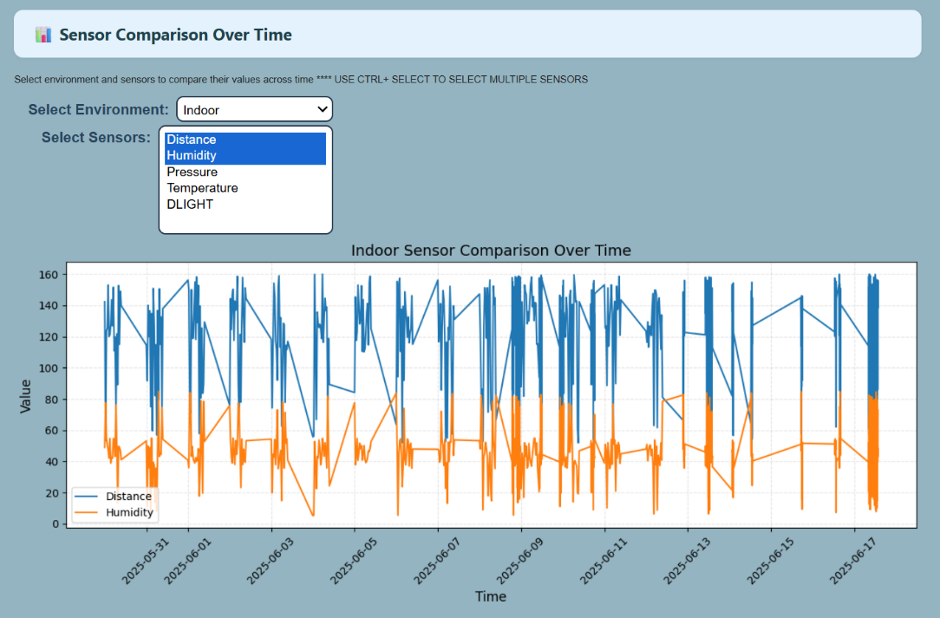
The Sensor Comparison Over Time section allows users to analyze how different sensor values change over a selected time period. Users can choose an environment, such as indoor or outdoor, and select multiple sensors by holding the CTRL key (or Command on Mac). The resulting graph visualizes the data from the selected sensors, enabling easy comparison of trends, fluctuations, and potential anomalies across time.
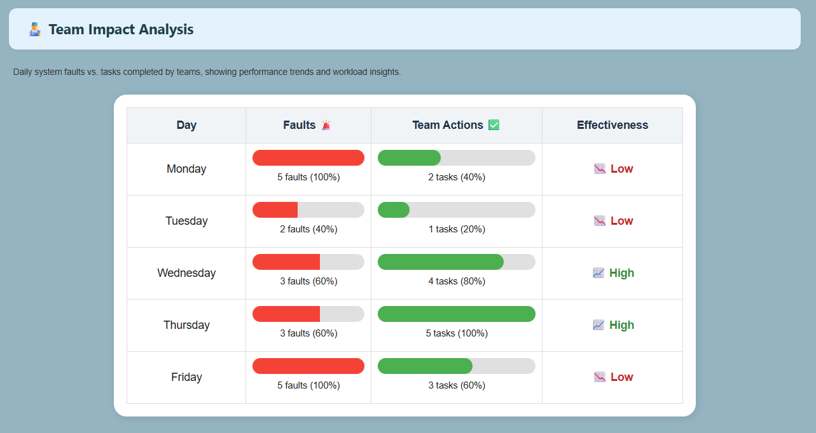
The Weekly Team Performance Analysis Chart displays, for each day, the number of system faults alongside the number of tasks actually completed by all teams. Combining these two data points allows calculating an overall performance metric that reflects the teams’ effectiveness and responsiveness over time. This chart helps identify unusual workload peaks, assess the teams’ ability to handle faults, and generate insights for process improvement.
Meetings
This screen provides a simple and intuitive interface for scheduling and managing team meetings.
- On the left side, users can fill out and submit a form to schedule a new meeting by selecting a team, date, time, location, and adding notes.
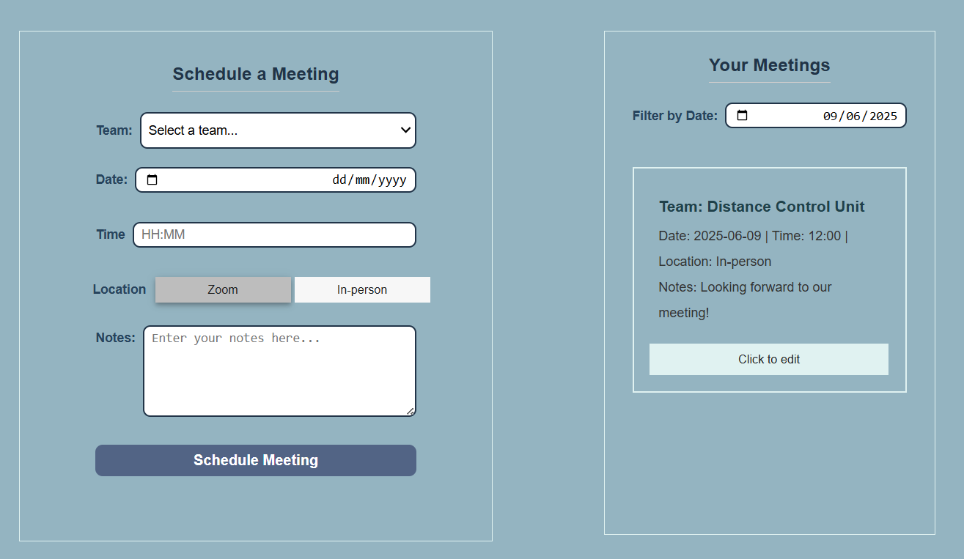
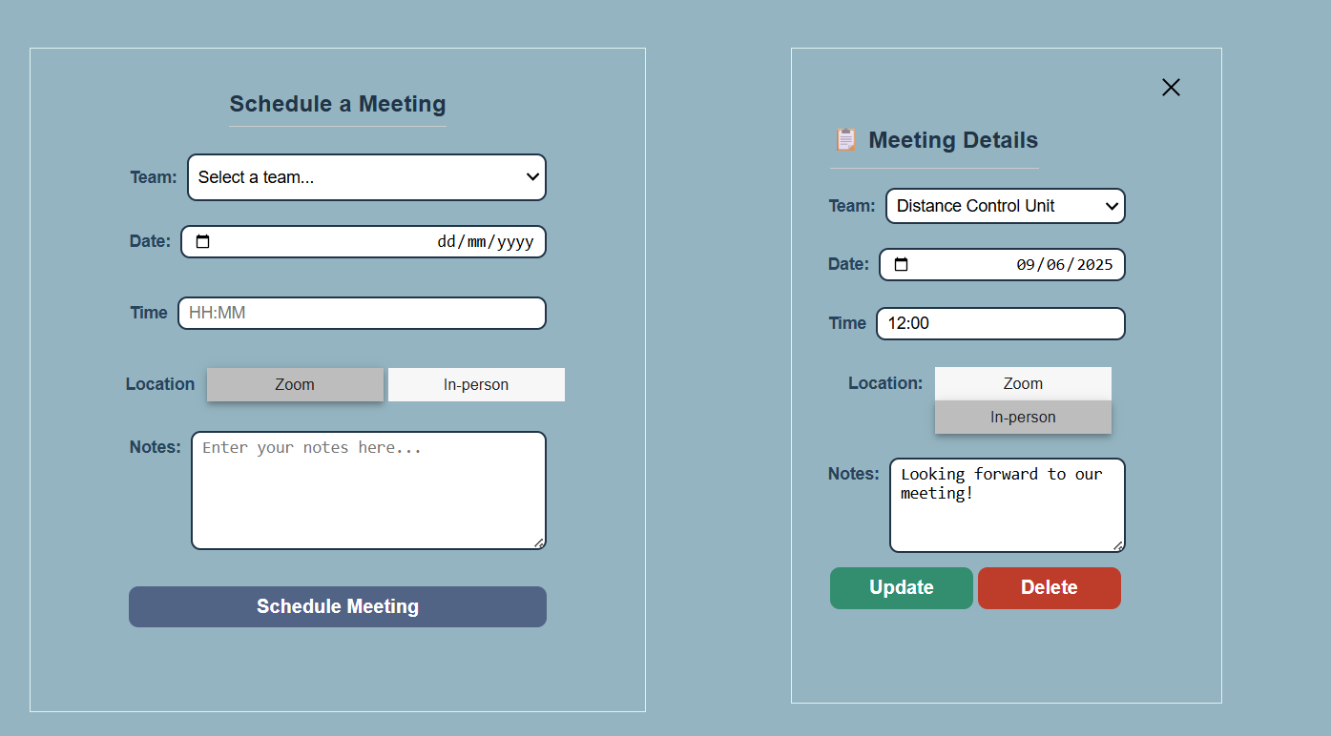
- On the right side, the manager can view all scheduled meetings, filtered by date. Each meeting is displayed with full details and includes an Edit button, which allows the manager to modify or delete the meeting.
After clicking the "Click to Edit" button
Rates
The screen displays a daily dashboard for evaluating engineer performance. It shows the number of engineers, average score, and the leading engineer. Each engineer's score, progress percentage, and task completion levels are presented. The goal is to track performance and encourage improvement and efficiency.
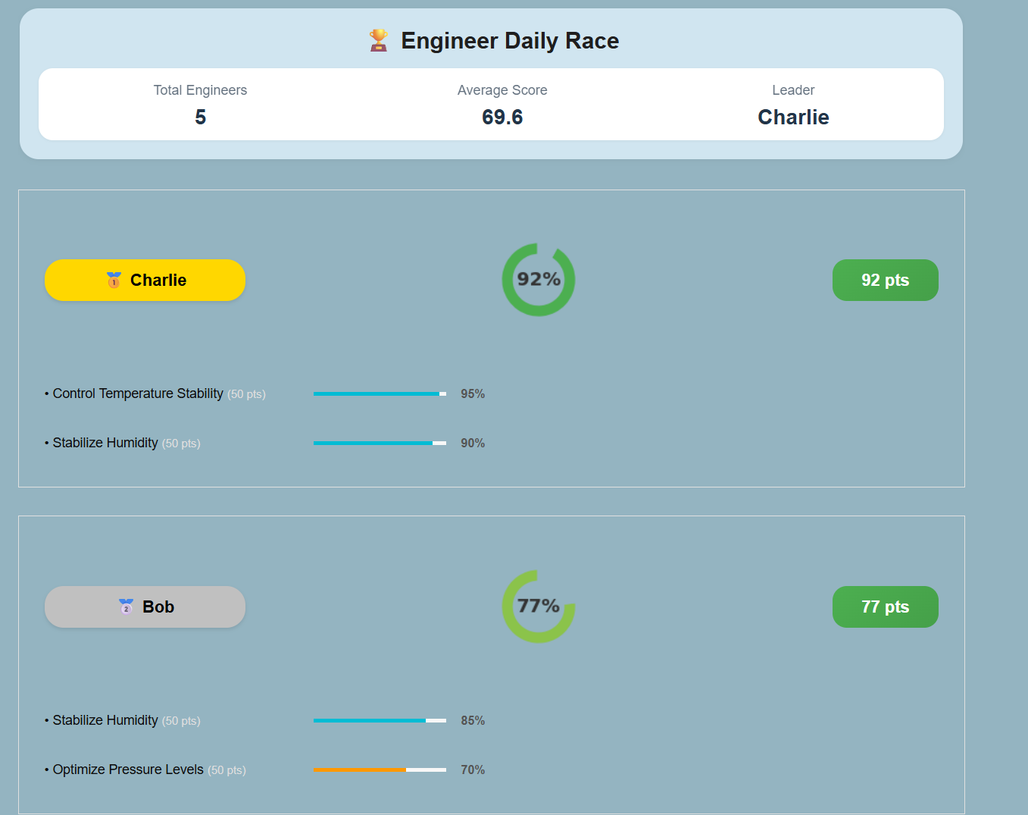

Teams Overview
The screen displays a Team Overview dashboard. Each section highlights a main task with a colored progress bar indicating completion status. Subtasks are listed beneath, each marked with status icons (✓ for completed, ✗ for not completed), providing a clear visual summary of team progress.
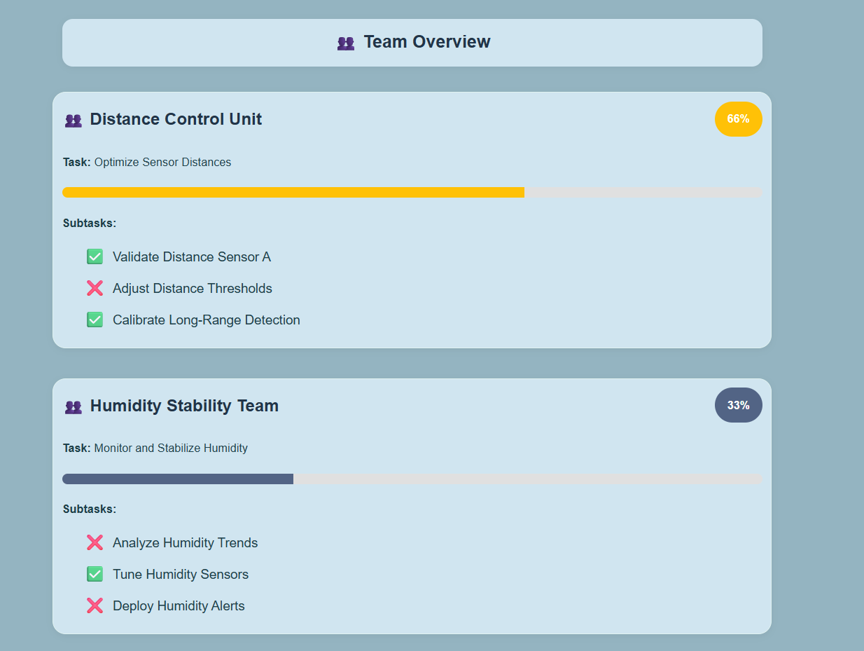

Chatbot
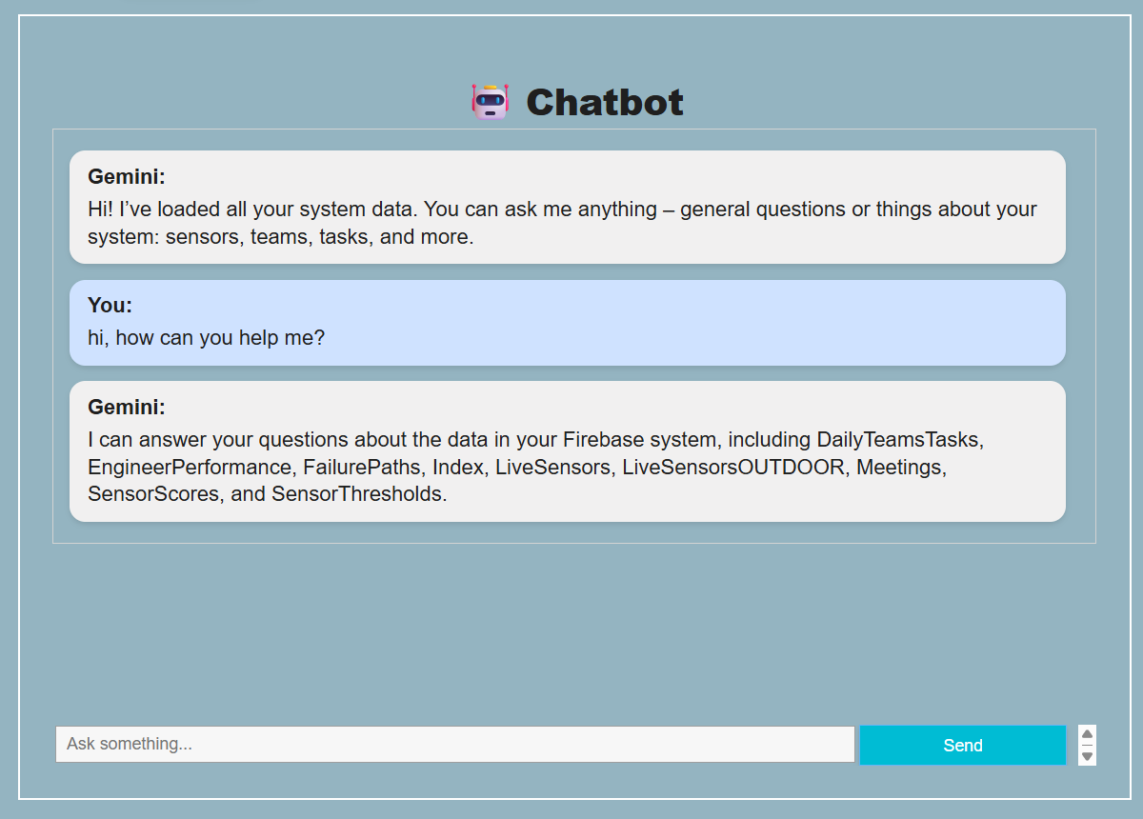
Shows an interactive chatbot interface that allows users to get real-time answers to various questions related to the system, sensors, teams, engineers and tasks.

